**Shell Script Assignment**

Q 1. Create a script named “myscipt” in current directory to do the following.

1. Display “hello user”

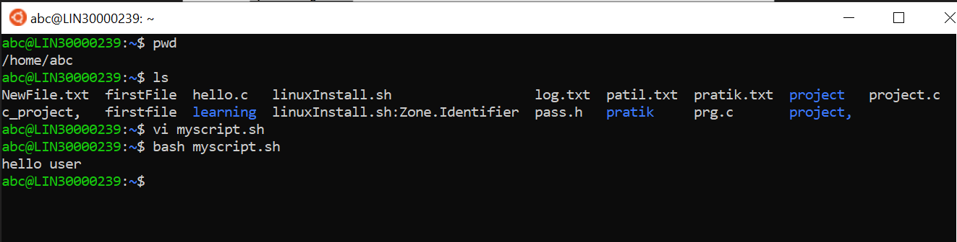

1. List files in current directory.